MNIST classification assignment

19512087 데이터사이언스학과 정영상

1. the number of model parameters

1. LeNet-5 model

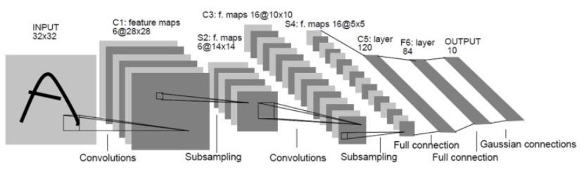

|  |  |  |
| --- | --- | --- |
| Layer (type) | Output Shape | Param |
| Conv2d - 1 | [-1, 6, 28, 28] | 156 |
| Tanh - 2 | [-1, 6, 28, 28] | 0 |
| AvgPool2d - 3 | [-1, 6, 14, 14] | 0 |
| Conv2d - 4 | [-1, 16, 10, 10] | 2,416 |
| Tanh - 5 | [-1, 16, 10, 10] | 0 |
| AvgPool2d - 6 | [-1, 16, 5, 5] | 0 |
| Linear - 7 | [-1, 120] | 48,120 |
| Tanh - 8 | [-1, 120] | 0 |
| Linear - 9 | [-1, 84] | 10,164 |
| Tanh - 10 | [-1, 84] | 0 |
| Linear - 11 | [-1, 10] | 850 |
| Softmax - 12 | [-1, 10] | 0 |

Total params: 61,706

Forward/backward pass Total params: 123,412

Training time: 1279.52s

Epoch: 10

Optimizer: SGD

Batch size: 32

1. Custom model

|  |  |  |
| --- | --- | --- |
| Layer (type) | Output Shape | Param |
| Linear – 1 | [-1, 64] | 50,240 |
| Dropout – 2 | [-1, 64] | 0 |
| ReLU – 3 | [-1, 64] | 0 |
| Linear – 4 | [-1, 64] | 4,160 |
| Dropout – 5 | [-1, 64] | 0 |
| ReLU – 6 | [-1, 64] | 0 |
| Linear – 7 | [-1, 64] | 4,160 |
| Dropout – 8 | [-1, 64] | 0 |
| ReLU – 9 | [-1, 64] | 0 |
| Linear – 10 | [-1, 32] | 2,080 |
| Dropout – 11 | [-1, 32] | 0 |
| ReLU – 12 | [-1, 32] | 0 |
| Linear – 13 | [-1, 16] | 528 |
| Dropout – 14 | [-1, 16] | 0 |
| ReLU – 15 | [-1, 16] | 0 |
| Linear – 16 | [-1, 16] | 272 |
| Dropout – 17 | [-1, 16] | 0 |
| ReLU – 18 | [-1, 16] | 0 |
| Linear – 19 | [-1, 10] | 170 |
| Dropout – 20 | [-1, 10] | 0 |
| ReLU - 21 | [-1, 10] | 0 |
| Linear – 22 | [-1, 10] | 110 |
| Softmax – 23 | [-1, 10] | 0 |

Total params: 61,720

Forward/backward pass Total params: 123,440

Training time: 1209.29s

Epoch: 10

Optimizer: SGD

Batch size: 32

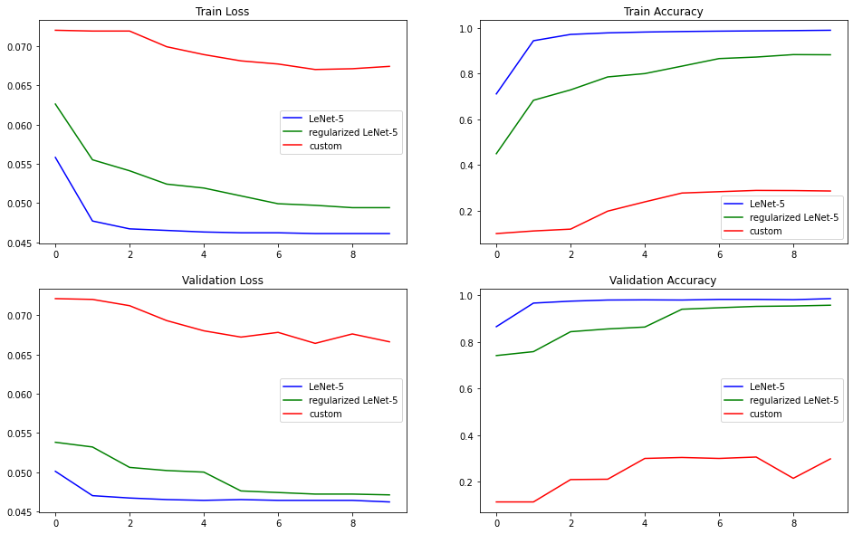

2. Average loss value and accuracy

(1) LeNet-5

Average training accuracy: [0.7111, 0.9439, 0.9715, 0.9783, 0.9819, 0.9842, 0.9858, 0.9870, 0.9882, 0.9897]

Average training loss = [0.0558, 0.0477, 0.0467, 0.0465, 0.0463, 0.0462, 0.0462, 0.0461, 0.0461, 0.0461]

Average validation accuracy = [0.8653, 0.9664, 0.9747, 0.9796, 0.9803, 0.9796, 0.9823, 0.9823, 0.9810, 0.9856]

Average validation loss = [0.0501, 0.0470, 0.0467, 0.0465, 0.0464, 0.0465, 0.0464, 0.0464, 0.0464, 0.0462]

(2) Custom model

Average training accuracy = [0.0996,0.1110, 0.1190, 0.1978, 0.2384, 0.2771, 0.2829, 0.2885, 0.2879, 0.2859]

Average training loss = [0.0720, 0.0719, 0.0719, 0.0699, 0.0689, 0.0681, 0.0677, 0.0670, 0.0671, 0.0674]

Average validation accuracy = [0.1135,0.1135, 0.2094, 0.2109, 0.3001, 0.3042, 0.3001, 0.3061, 0.2148, 0.2983]

Average validation loss = [0.0721, 0.0720, 0.0712, 0.0693, 0.0680, 0.0672, 0.0678, 0.0664, 0.0676, 0.0666]

1. Regularized LeNet-5

Average training accuracy = [0.4493, 0.6832, 0.7287, 0.7854, 0.8000,0.8326, 0.8657, 0.8724, 0.8831, 0.8824]

Average training loss = [0.0626, 0.0555, 0.0541, 0.0524, 0.0519, 0.0509, 0.0499, 0.0497, 0.0494, 0.0494]

Average validation accuracy = [0.7414, 0.7582, 0.8437, 0.8556, 0.8637, 0.9401, 0.9465, 0.9523, 0.9540, 0.9573]

Average validation loss = [0.0538, 0.0532, 0.0506, 0.0502, 0.0500, 0.0476, 0.0474, 0.0472, 0.0472, 0.0471]

3. Comparison LeNet-5 and Custom MLP

평균 loss값은 custom model이 가장 높게 나왔으며 epoch을 늘릴 경우 regularization model의 loss는 점점 낮아질 것으로 예상된다. 평균 accuracy의 경우 LeNet-5 모델이 가장 높았으며 마찬가지로 epoch을 늘릴 경우 regularization model의 accuracy가 증가할 것으로 보인다.

4. Regularization techniques

1. Regularized LeNet5

ReLU activation function

Maxpooling

Dropout / p = 0.5

L2 Regularization(weight decay / 0.001)

Total params: 61,706

Forward/backward pass Total params: 123,412

Training time: 1470.43s